# Lab: Interval Trees, K-d Trees

This document defines the **in-class exercises** assignments the ["Data Structures" course @ Software University](https://softuni.bg/opencourses/data-structures).   
Submit your code in the SoftUni Judge - <https://judge.softuni.bg/Contests/Practice/Index/644#0>

## Interval Tree

You are given a skeleton. Implement the following operations:

* Interval SearchAny(int, int) 🡪 returns any interval that intersects with a given lower and upper bound
* IEnumerable<Interval> SearchAll(int, int) 🡪 returns all intervals that intersect the given lower and upper bound

|  |
| --- |
| public class IntervalTree  {  private Node root;  public void Insert(double start, double end) { … }  public Interval SearchAny(double start, double end) { … }  public IEnumerable<Interval> SearchAll(double start, double end) { … }  } |

### Solution

You will need to update the max endpoint whenever you insert (or delete/balance) a node

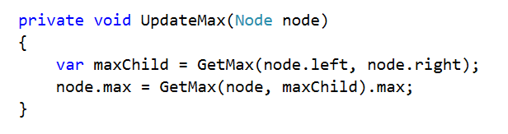

GetMax() returns the node that has greater max endpoint, while guarding against null values

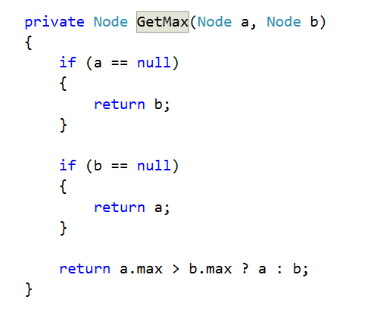

Search for any interval that intersects given bounds

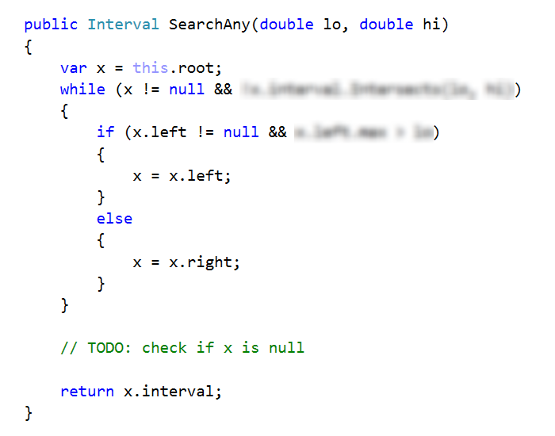

Searching for all intervals will do a recursive DFS, so you will need one method to call the recursion

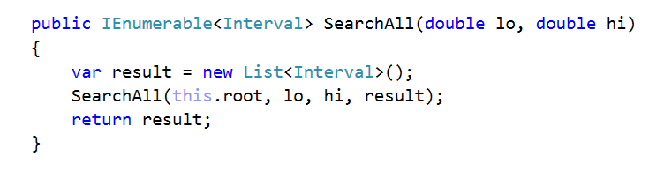

And the actual DFS

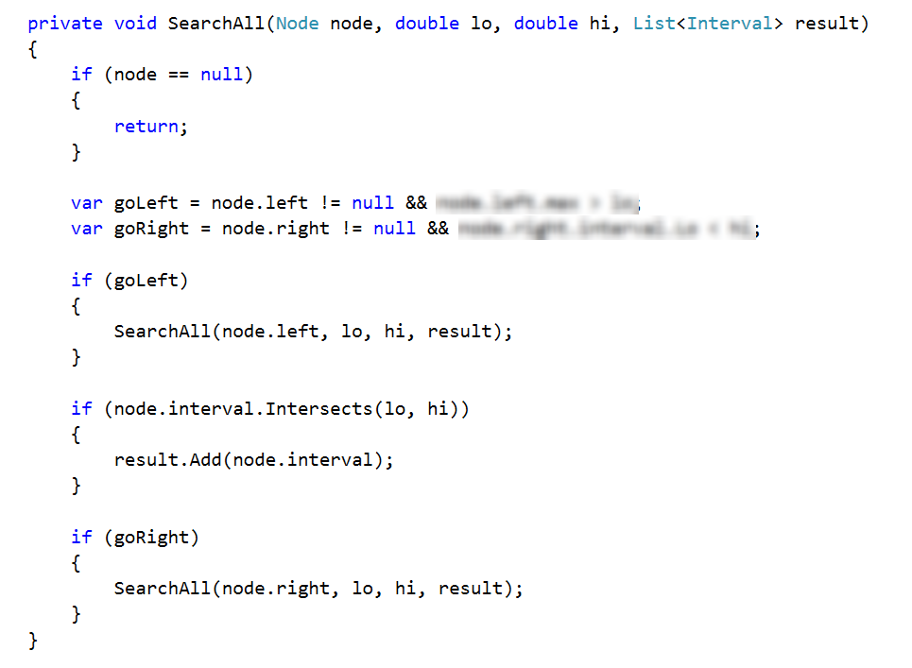

## K-d Tree

You are given a skeleton. Implement the following operations:

* void Insert(Point2D) 🡪 inserts a point into the tree
* bool Contains(Point2D) 🡪 shows if the tree contains a given point

|  |
| --- |
| public class KdTree  {  private Node root;  public void Insert(Point2D point) { … }  public bool Contains(Point2D point) { … }  public void EachInOrder(Action<Point2D> action) { … }  } |

### Solution

The only thing different than a regular BST is the comparison. Create a method that will compare the point in a node and a second point, depending on the node depth

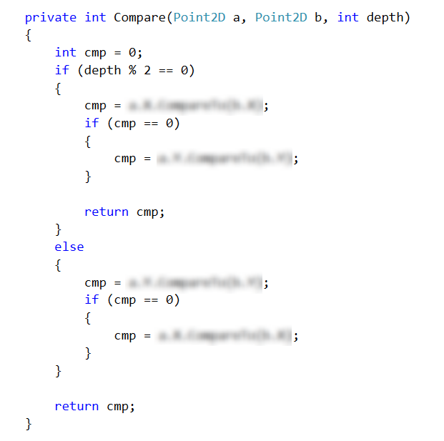

The other thing to consider is to pass the depth of a node when attemting to insert or search for a point

